ASSIGNMENT #2
Course title: Programming Fundamental Class: BSCS-25-l Submitted to: Mr. Tassadaq Latif Submitted by: Saad Arshad Roll No: 25014119-184 Submission date: 03-13-2025

Solution of Mid Paper
Q#1: Find error or write output of the code?
(a)
Sol: Screenshots:
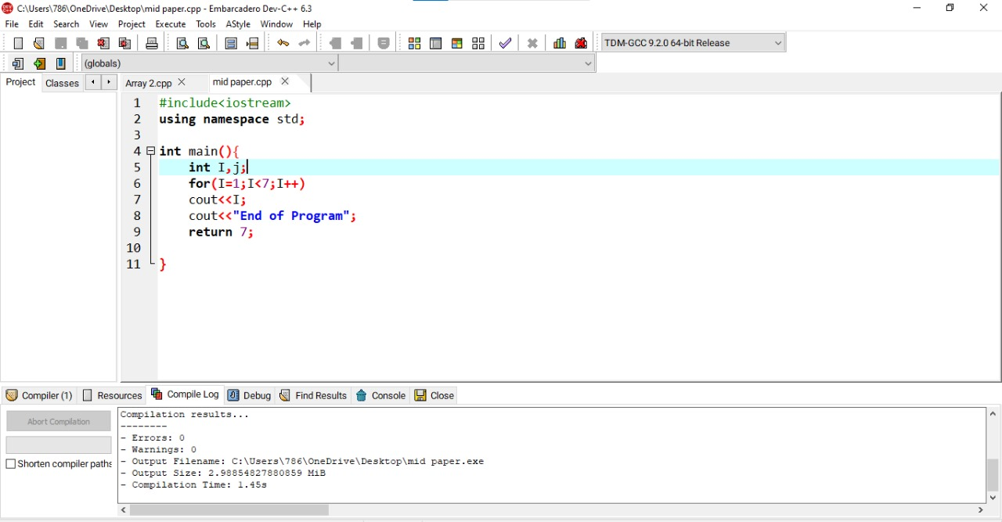
‘’OUTPUT’’
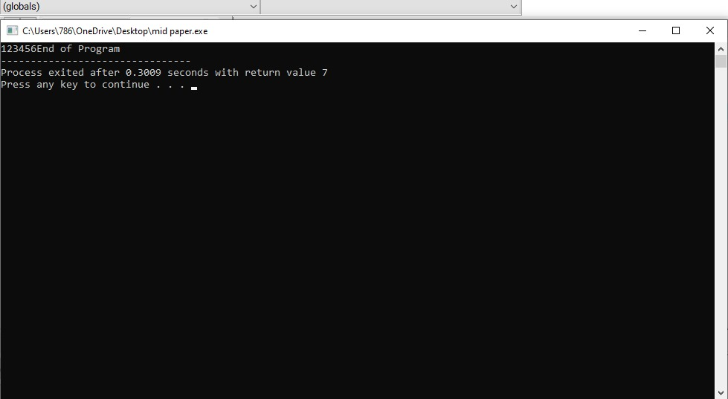

(b)
Screenshot:
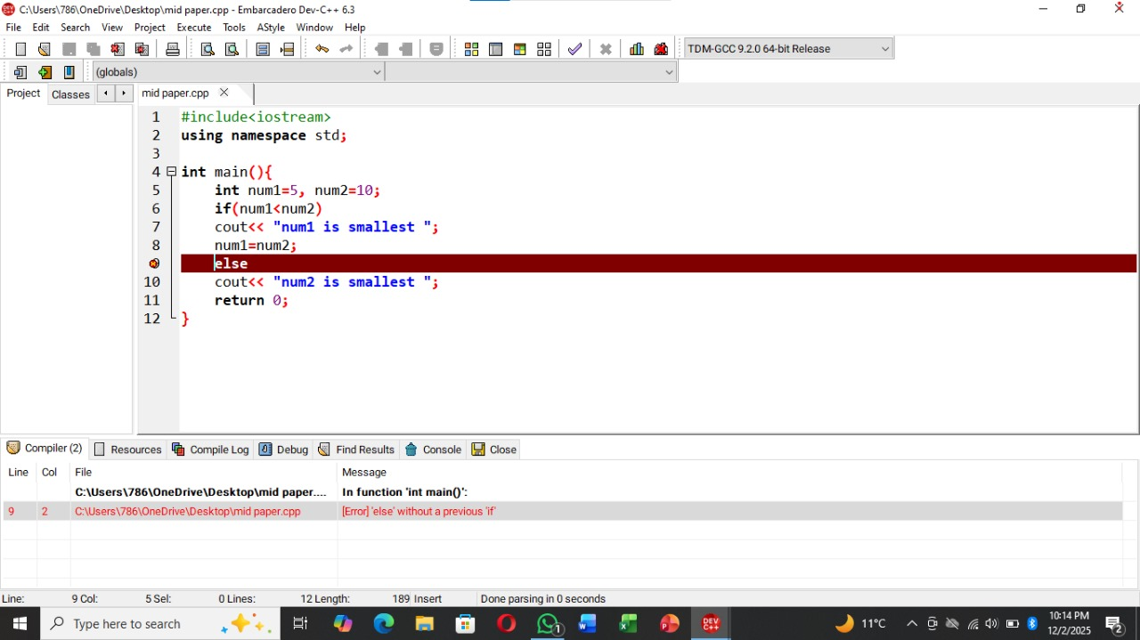
There is a syntax error in its structure body of if else condition.

(c)
Screenshot:
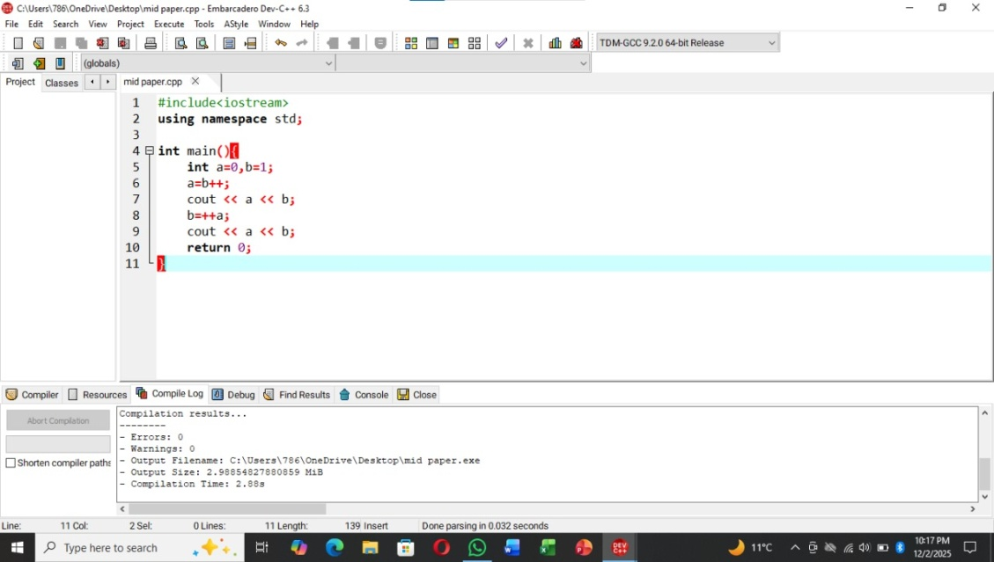
OUTPUT
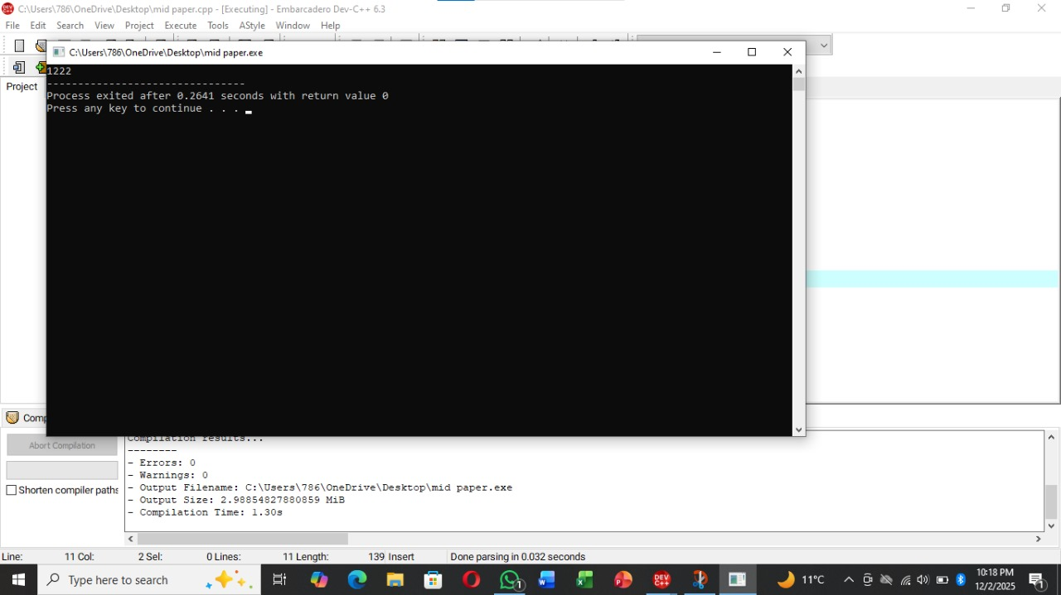

(d)
Screenshot:
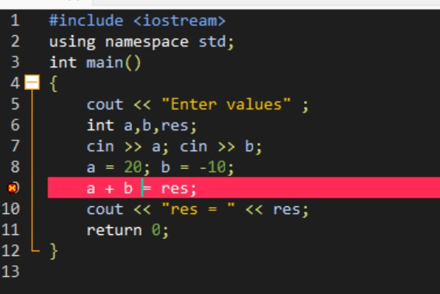
There is a error in a+ b arithmetic rule in which cannot be accomplished because this side is used to sign the value so it is called syntax error of c programme.

Q#2
‘’Height in feet and inches’’
#include <iostream>
using namespace std;
int main (){
long int height, feet;
cin>>height;
feet=height/12;
int remaiing_inch=height% 12;
cout<<"height in feet"<<feet<<endl;
cout<<"remaining inchhes"<< remaiing_inch;
}
Output:
65
height in feet 5
remaining inchhes 5

Q#3
‘’Multiple of a and b’’
#include <iostream>
using namespace std;
int main (){
int a, b;
a=49;
b=7;
if (a% b==0){
cout<<"b is multiply of a"<<endl;
} else{
cout<<"not multiply"<<endl;
}

}
Output:
b is multiply of a

Q#4
MINIMUM,MAX AND SUM
#include <iostream>
using namespace std;
int main() {
int number;
int sum = 0;
int maximum = INT_MIN;
int minimum = INT_MAX;
for (int i = 0; i < 10; i++) {
cout<<"Enter number:";
cin>>number;
sum += number;
if (number > maximum) {
maximum = number;
}
if (number < minimum) {
minimum = number;
}
}
cout<<"sum:"<<sum<<endl;
cout<<"Maximum number:"<<maximum<<endl;
cout<<"Minimum number:"<<minimum<<endl;
return 0;
}
Output:
Enter number: 1
Enter number: 2
Enter number: 3
Enter number: 4
Enter number: 5
Enter number: 6
Enter number: 7
Enter number: 8
Enter number: 9
Enter number: 0
sum: 45
Maximum number: 9
Minimum number: 0

‘’ARRAY SORTING’’
Q#1
Selection sort:
#include <iostream>
using namespace std;
int main() {
int arr[] = {64, 25, 12, 22, 11};
int n = sizeof(arr) / sizeof(arr[0]);
int i, j, min_idx, temp;

for (i = 0; i < n - 1; i++) {
min_idx = i;
for (j = i + 1; j < n; j++) {
if (arr[j] < arr[min_idx]) {
min_idx = j;
}
}
temp = arr[min_idx];
arr[min_idx] = arr[i];
arr[i] = temp;
}
cout<<"Selection Sort:";
for (i = 0; i < n; i++) {
cout<<arr[i]<<endl;
}
return 0;
}
Output:
Selection Sort:11
12
22
25
64

Q#2
Bubble sort:
#include <iostream>
using namespace std;
int main() {
int arr[] = {64, 34, 25, 12, 22, 11, 90};
int n = sizeof(arr) / sizeof(arr[0]);
int i, j, temp;
for (i = 0; i < n - 1; i++) {
for (j = 0; j < n - i - 1; j++) {
if (arr[j] > arr[j + 1]) {
temp = arr[j];
arr[j] = arr[j + 1];
arr[j + 1] = temp;
}
}
}
cout<<"Bubble Sort:";
for (i = 0; i < n; i++) {
cout<<arr[i]<<endl;
}
return 0;
}
Output:
Bubble Sort:11
12
22
25
34
64
90

Q#3
Insertion sort:
#include <iostream>
using namespace std;
int main() {
int arr[] = {12, 11, 13, 5, 6};
int n = sizeof(arr) / sizeof(arr[0]);
int i, key, j;

for (i = 1; i < n; i++) {
key = arr[i];
j = i - 1;

while (j >= 0 && arr[j] > key) {
arr[j + 1] = arr[j];
j = j - 1;
}
arr[j + 1] = key;
}
cout<<"Insertion Sort:";
for (i = 0; i < n; i++) {
cout<<arr[i]<<endl;
}
return 0;
}
Output:
Insertion Sort:5
6
11
12
13

Q#4
Descending sort:
#include <iostream>
using namespace std;
int main() {
int arr[] = {64, 34, 25, 12, 22, 11, 90};
int n = sizeof(arr) / sizeof(arr[0]);
int i, j, temp;

for (i = 0; i < n - 1; i++) {
for (j = 0; j < n - i - 1; j++) {
if (arr[j] < arr[j + 1]) {
temp = arr[j];
arr[j] = arr[j + 1];
arr[j + 1] = temp;
}
}
}

cout<<"Descending: ";
for (i = 0; i < n; i++) {
cout<<arr[i]<<endl;
}
return 0;
}
Descending: 90
64
34
25
22
12
11

Q#5
Ascending:
#include <iostream>
using namespace std;
int main() {
int arr[] = {64, 25, 12, 22, 11};
int n = sizeof(arr) / sizeof(arr[0]);
int i, j, max_idx, temp;

for (i = 0; i < n - 1; i++) {
max_idx = i;
for (j = i + 1; j < n; j++) {
if (arr[j] > arr[max_idx]) {
max_idx = j;
}
}
temp = arr[max_idx];
arr[max_idx] = arr[i];
arr[i] = temp;
}

cout<<"Ascending:";
for (i = 0; i < n; i++) {
cout<<arr[i]<<endl;
}
return 0;
}

Output:
Ascending:64
25
22
12
11

